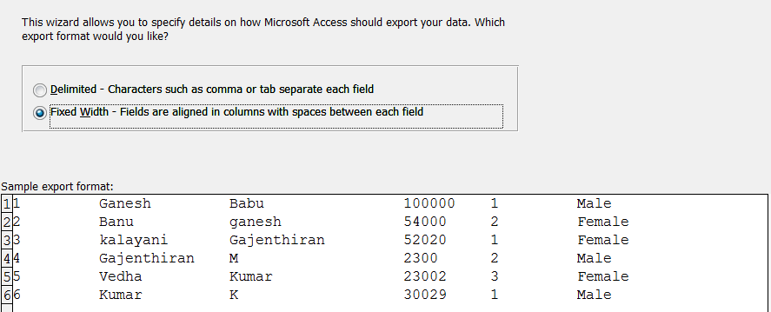

Position for the fixlength

Like Name

employee_id as POSITION(1,10),  
